**LAB 1**

**AIM: Getting familiar with MATLAB and performing basic operations on image.**

MATLAB BASICS

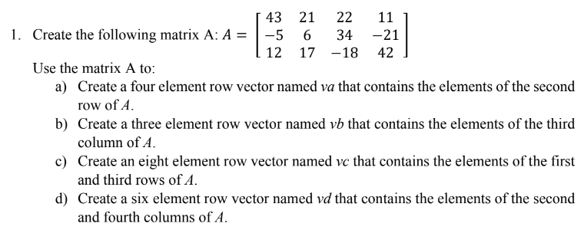

a)

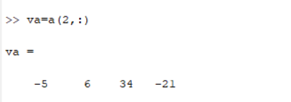

b)

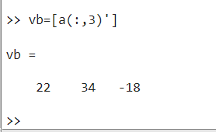

c)

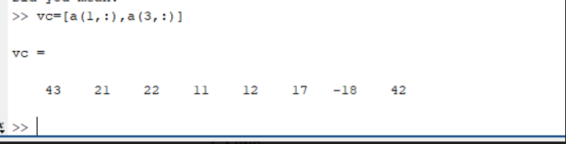

d)

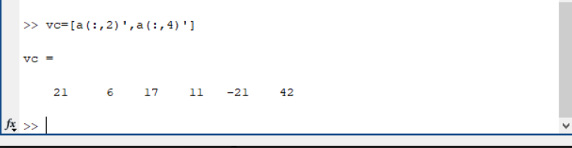

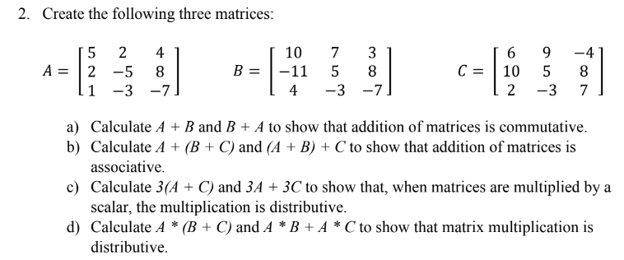

a)

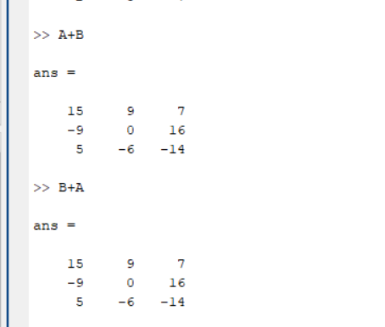

b)

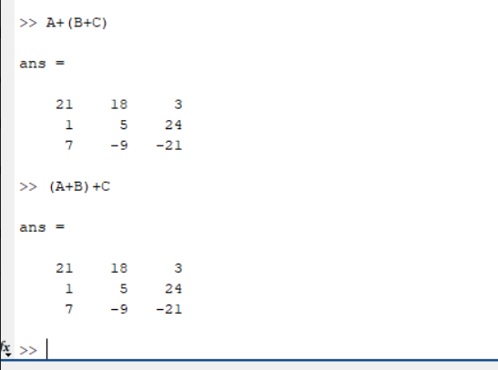

c)

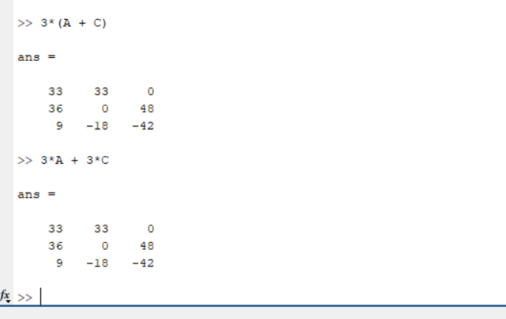

d)

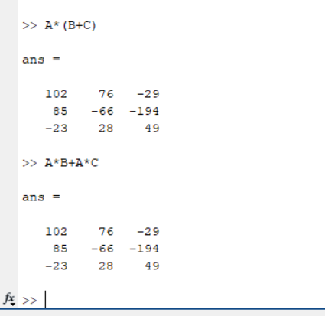

3. Create an array A = [1 2 3 4 5 6] and using built in functions for array find

a. length of A

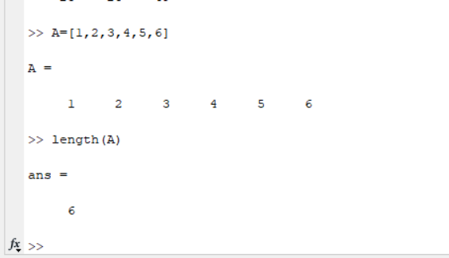

b. average of the elements of A

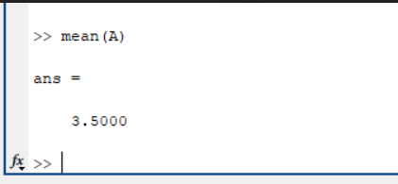

c. Maximum element of A

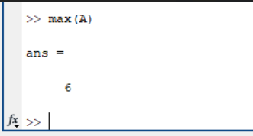

d. Minimum element of A

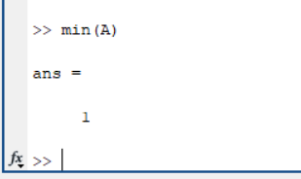

e. Sum of all the elements of A

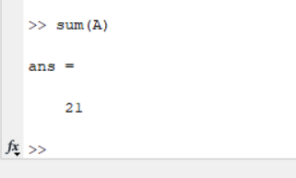

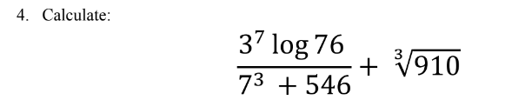

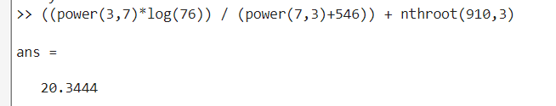

5. Using the ones and zeros commands, create a 4 x 6 matrix in which the first two rows are

0’s and the next two rows are 1’s.

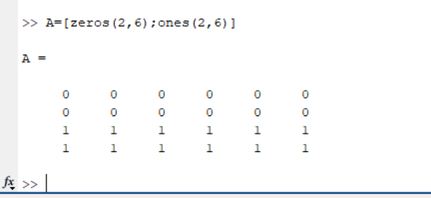

**IMAGE PROCESSING TOOLBOX IN MATLAB**

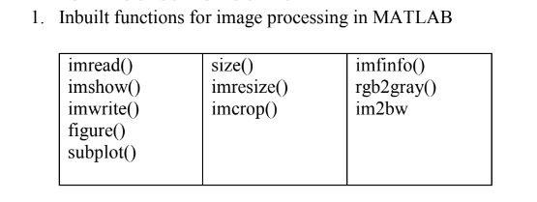

**imread():-**

Read images from various file formats. Read an image as a matrix from the file FILENAME or from the online resource URL.

**imshow():-**

Display the image IM, where IM can be a 2-dimensional (grayscale image) or a 3-dimensional (RGB image) matrix.

**imwrite():-**

Write images in various file formats.

**figure():-**

Create a new figure window for plotting.

**subplot():-**

Set up a plot grid with ROWS by COLS subwindows and set the current axes for plotting ('gca') to the location given by INDEX.

**size():-**

Return a row vector with the size (number of elements) of each dimension for the object A.

**imresize():-**

Scales the image IM by a factor SCALE or into the size M rows by N columns.

**imcrop():-**

Displays the image IMG in a figure window and waits for the user to select two points defining a bounding box.

**imfinfo():-**

Returns a structure containing information about the image stored in the file FILENAME.

**rgb2gray():-**

Transform an image or colormap from red-green-blue (RGB) color space to a grayscale intensity image.

**im2bw():-**

Convert image to binary, black and white, by threshold.

2. Take your own photo (RGB image) and create the following images and save them

for future use

a) Gray scale image

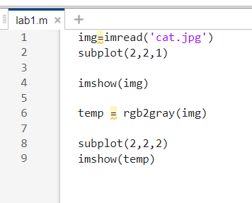

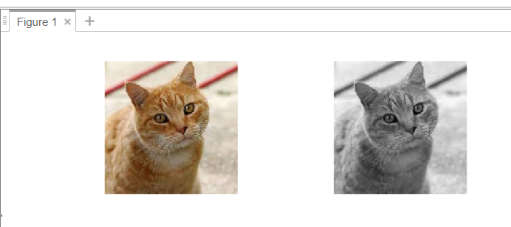

b) Black and White image

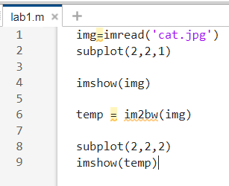

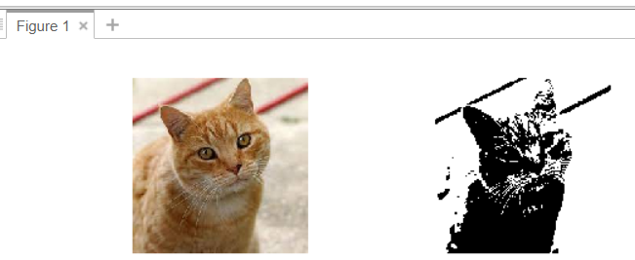

c) Over exposed image

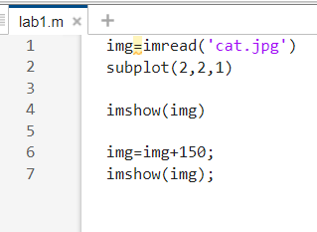

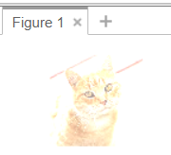

d) Under exposed image

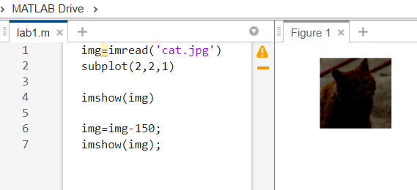

e) Keep your face only and crop the rest of the part

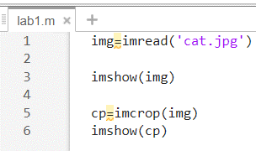

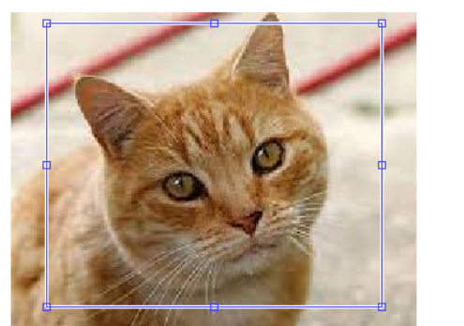

f) Resize the image to 256 x 256

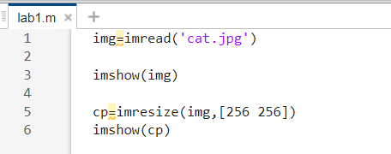

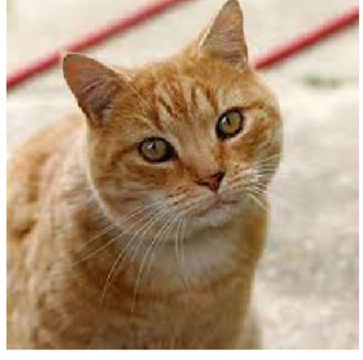

3. Take you own photo and process them for following results using loop controlling

structures.

a. Flip your image vertically

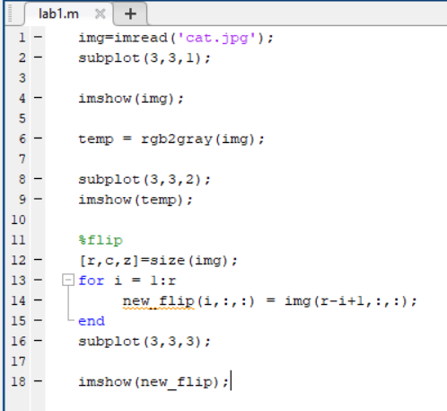

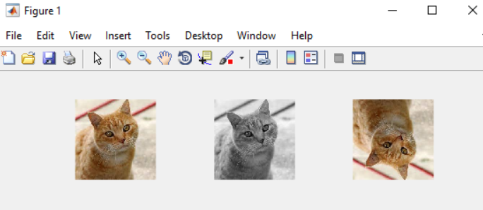

b. Create the mirror image

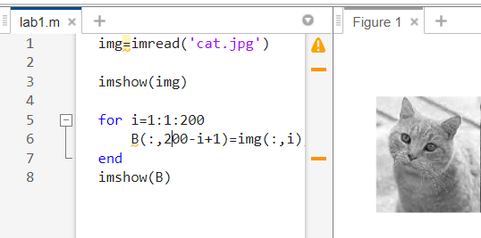

c. Rotate the image by 90 degrees.

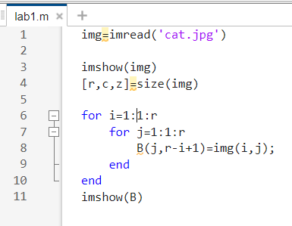

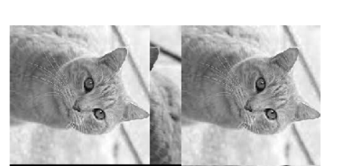

d. Rotate the image by 270 degrees.

